OBJECTIVES:
Be able to graph the sine and cosine functions in both radians and degrees.
Note that the ranges of both y = sin x and y = cos x will be y-values between -1 and 1.
Sine Function:
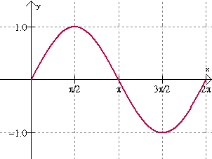
Cosine Function:
For both the sine and cosines graphs here:
called a "wave" because of its rolling wave-like
appearance
amplitude: 1
period:
frequency: 1 cycle in radians
domain:
range:

Did you notice that the cosine curve is really the exact same graph as the sine curve shifted 90º (or radians) to the left?

THURSDAY (11.7.24)

At the beginning of this class, turn in your Take-Home Quiz: Use the Five Point Method to graph one period of a given sine function.
Discuss how to graph the cosine function, using The Five Point Method.
Class Work: Graph these functions on the same coordinate plane.
- y = cos (0.5(x-45))º + 1.
- y = sin (0.5(x-45))º + 1.
Class Work/Homework:
Graph the one period for each of the following functions, using formats discussed in class.
(1) y = 6sin (3(x + 50)) º
(2) y = -4cos(9(x-10)) º + 3
(3) The height of the tide in a small beach town is measured along a seawall. Water levels oscillate between 7 feet at low tide and 15 feet at high tide. On a particular day, low tide occurred at 6 AM and high tide occurred at noon. Approximately every 12 hours, the cycle repeats. Find a cosine model, using degrees, for the water levels.
FRIDAY (11.8.24)

Discuss the previously assigned class work/homework.

Class Work/Homework: Graph the following, using The Five Point Method and radians.
- y = sin x
- y = cos x
- y = 4sin (0.2x)
- y = 4cos (0.2x)
- y = -2sin (πx) + 1
- y = -2cos (πx) + 1
- y = 2sin (2(x – 0.5π)) – 1

